|  |  |  |  |  |  |  |
| --- | --- | --- | --- | --- | --- | --- |
| **Document No:** VOD-MAN-PRC-XXXX | | Server Commission process | | | | **Rev. 1.0** |
| **Applicable areas of business**  Enterprise IT Division | | | **Responsible Division**  Enterprise IT Division | | | |
| **Approval** | **Name and Job Title** | | | **Approval** | **Approved Date** | |
| **Owner** | Jannie Pretorius | | |  |  | |
| **Approval by** | Mike van den Berg – Manager:  Service Management Enablement | | |  |  | |
| **Approved by** | Trevor Owen EHOD: Enterprise IT | | |  |  | |

Table of Contents

1. INTRODUCTION 1

2. GOALS 1

3. OBJECTIVES 1

4. APPLICABILITY 1

5. SOLUTION 1

6. HIGH LEVEL PROCESS 1

7. DETAILED CHANGE REQUESTER PROCESS 1

8. PROCESS RACI 1

# INTRODUCTION

This process will be used to commission a server CI. The process will focus on the Change Control process for commissioning a server in the infrastructure. The process will

Following the Change Control process for decommissioning servers is the Vodacom preferred method as this will assist change management managing the risk and impact of the infrastructure.

After a successful decommission the server CI (In the CMDB) record Life cycle status will be set to “Disposed” , the record will be soft deleted. (Not visible for any another process module in the CMDB)

# GOALS

The goals of this process is to ensure the correct Change Management server commission process are followed. If any server are commissioned into the infrastructure without following the Server commission Change process it will be reported as a unauthorized change,

# OBJECTIVES

1. Configuration Management Objective: Update the related CMDB CI Record to “Deployed”
2. after approval and confirmation from the Change Commission task implementer confirmed the task is complete
3. Change management objective : Control the server infrastructure.

# APPLICABILITY

This process is applicable to all Operational environment in Vodacom including.

# SOLUTION

Applicable solutions: Remedy Asset Management, Change request records.

# HIGH LEVEL PROCESS

**Change Requester**

1. Execute the Commission Change Request for infrastructure servers
2. Ensure that all the effected CI’s are related to the change request.

**Note**:

*User the Server CI Create process to create the Server if the CI Record does not exist*

**System Administrator executing the Decommission task**

1. Commission/ Install the server in the Vodacom Infrastructure
2. Update the Commission Change Decommission task to Complete (This is to confirm that all the task above is done)

**Note**

*Configuration management will only be able to update the CI Record to Deployed* ***after*** *the Server Commission task completed.*

**Change office responsibilities towards the decommission**

1. Ensure the approvals are obtained
2. Ensure the risk of the commission/installations is determined
3. Ensure that the commission and associated task are executed.
4. Instruct (Via the completion of the Change Commission Task) Configuration Management to decommission CI Record.

**Configuration Management**

1. Update the server/s CI Record to “Deployed”
2. Accept or Reject the Request / Change task to decommission
3. Communicate any rejections or the change Office or requester
4. Communicate any other anomalies to the change office

# DETAILED CHANGE REQUESTER PROCESS (The process below belongs to the Change management Office)

**Note**: *Please communicate with Change management Office if you have any Questions to the process below.*

**There are two key steps in Remedy for submitting a change request to commission/install a server**

1. **Using the Correct Change Template:**

Use the Remedy Change Template **,:”Server Infrastructure >> Commission >> Commission Server”**

1. **Relating the Correct CI/s**

When relating the Configuration item to the change request it is important to select the correct

server name. If the incorrect server is chosen, the incorrect server life cycle will be change

to deployed in the CMDB and could have a negative impact on all other processes.

**Snapshot 1**

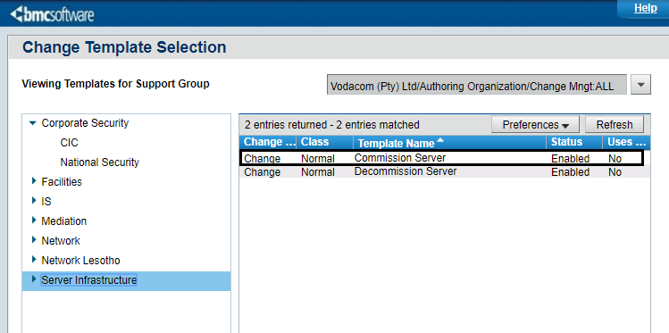

**Please note below, besides CMDB updates, there may be some tasks related to commissioning which**

**must be driven by the server owner/administrator as is there is no automated commissioning process driver in place.**

|  |
| --- |
| * **Informing affected stakeholders to update relevant Systems and Databases**    + Topology, Inventory, Asset Management, Configuration Management and BCM/DRP etc.   + IT, Billing, Finance and Procurement Databases.   + Third Parties (Updating support contracts, SLAs and Bo’s). * **CMDB/Remedy updates (Incident, Change, Asset Management etc.)**   + Ensuring that CI’s are recorded as Deployed * **License Management**   + Updating License Management Systems and/or Library * **IP Management**   + Management of IP Resources (Ranges), DNS maintenance * **Security Information and Event Management (SIEM)**   + Informing the SIEM operations departments (i.e. Arc Sight, Spelunk, etc.) on server commissioning. * **Access Management**   + Arranging access management * **SOX Controls** * **Etc…**  Other tasks as is relevant to each service area |

# PROCESS RACI

|  |  |  |  |  |  |
| --- | --- | --- | --- | --- | --- |
| ***Step#*** | ***Action*** | ***Responsible*** | ***Accountable*** | ***Consulted*** | ***Informed*** |
|  | Register the Required change and Relate all the CI | Change Requester | Line Manager | Change Requester Line management | N/A |
|  | Approve the change | CI Owner or proxy | Line Manager |  | N/A |
|  | Manage risk and Approvals and decommission task | Change Office | Line Manager | Change office | N/A |
|  | Instruct Configuration Management to update CI Record after successful commissioning | Change Office | Line Manager | Change office | N/A |
|  | Update CI Record to Deployed | Configuration Management | Line Manager | EIT Configuration Management Team | EIT Configuration Management Team |